Old case
Make a case similar to this (old case):
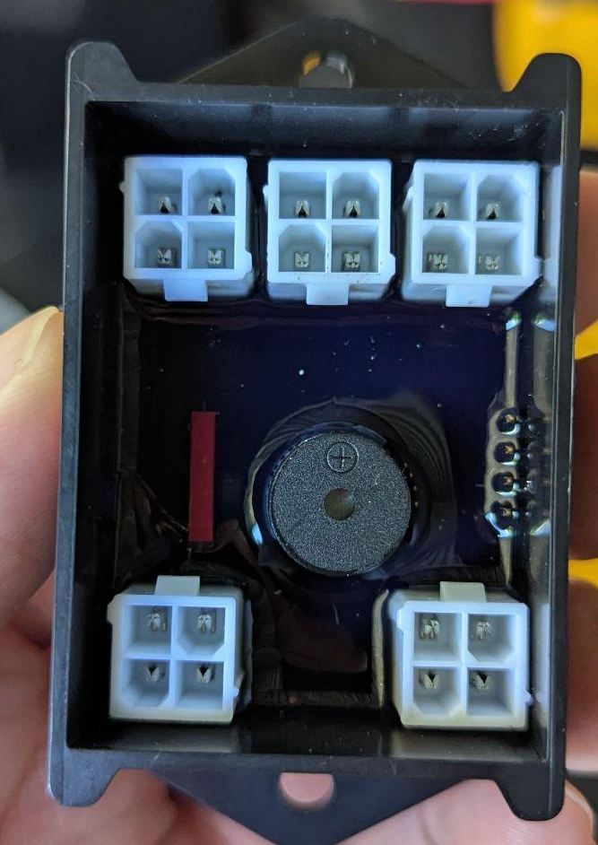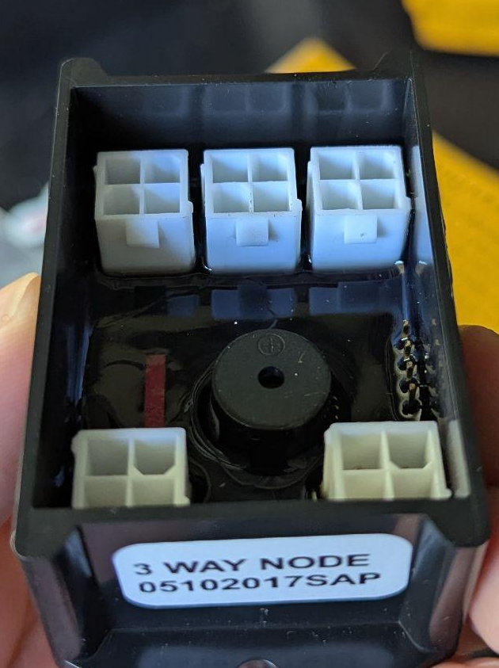

New case (2 pieces)
- The new case consists of 2 pieces - the main case and the cover.
- Case wall thickness: 2mm
- The case fits a PCB:
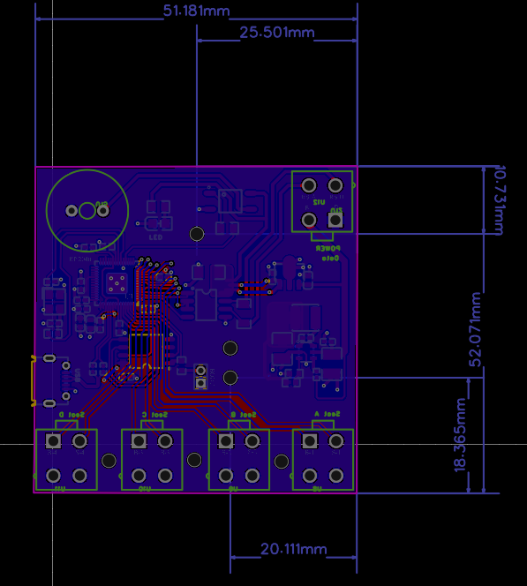

Main case

Side view
You will model the black and yellow
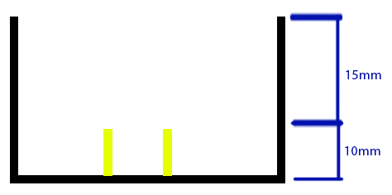
- Yellow: M2 screw support extended from bottom of case
- Black: Case

Bottom view
55mm x 55mm
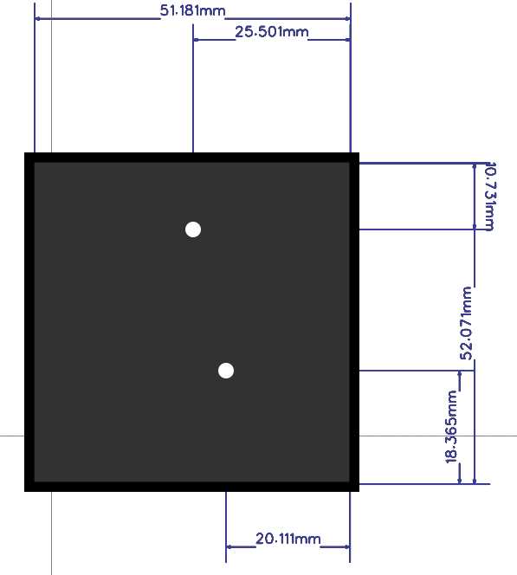

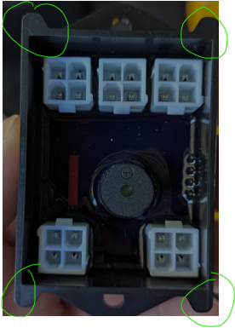
- Include supports like this

Case Cover
The case cover fits inside the main case. You will design the red and orange

Bottom View
Red: cover
Orange: supports 4mm diameter
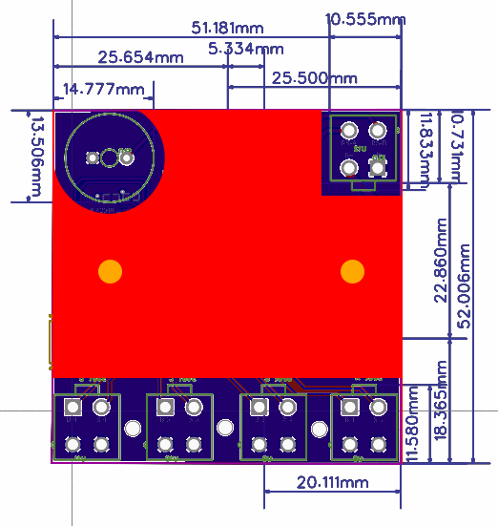

Side view
Red: cover
Orange: Supports
